EX NO: 2 | Configure VLANs and inter-VLAN routing in Packet Tracer
DATE:21/7/26

Objectives:
- To create and configure Virtual Local Area Networks (VLANs) for logical network segmentation and traffic isolation.
- To configure Inter-VLAN Routing to enable communication between devices belonging to different VLANs.

Software/Apparatus required:
  - Cisco Packet Tracer
  - End Devices (PCs)
  - Switches
  - Copper Straight-through Cable / Automatic Cable Selector
  - Routers

Procedure
Objective 1: VLAN Configuration
    - Open Cisco Packet Tracer.
    - Place two switches and six PCs in the workspace.
    - Connect the PCs to the switches using straight-through cables.
    - Connect the two switches using a crossover cable.
    - Create VLAN 10 and VLAN 20 on both switches.
    - Assign the ports connected to PC0, PC1, and PC2 to VLAN 10.
    - Assign the ports connected to PC3, PC4, and PC5 to VLAN 20.
    - Configure the link between the switches as a trunk link.
    - Configure the PCs with the required network settings.
    - Verify communication between devices belonging to the same VLAN.
    - Verify that communication between devices in different VLANs is not possible.
    - Save the configuration and observe the results.

Objective 2: Inter-VLAN configuration
- Open Cisco Packet Tracer.
- Place one router, three switches, and six PCs in the workspace.
- Connect the PCs to their respective switches using straight-through cables.
- Connect the access switches to the central switch.
- Connect the router to the central switch.
- Create VLAN 10 and VLAN 20 on the switches.
- Assign the ports connected to PC0, PC1, and PC2 to VLAN 10.
- Assign the ports connected to PC3, PC4, and PC5 to VLAN 20.
- Configure the links between the switches as trunk links.
- Configure the router interfaces to route traffic between VLAN 10 and VLAN 20.
- Configure the required network settings on all PCs.
- Verify communication between devices within the same VLAN.
- Verify communication between devices belonging to different VLANs through the router.
- Save the configuration and observe the results. 15.

Networking diagram:
Objective 1: VLAN Configuration
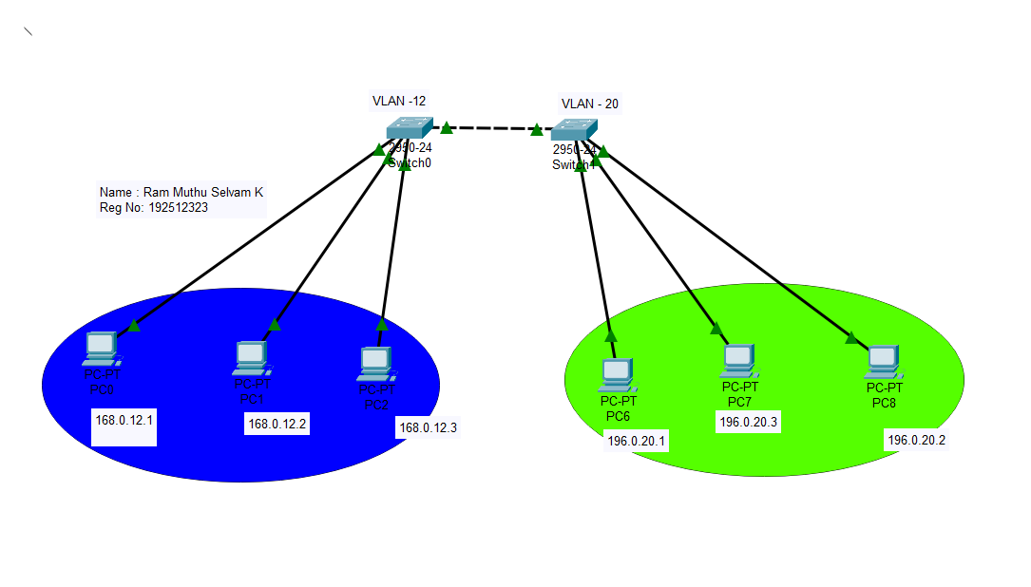

Objective 2: Inter-VLAN Configuration

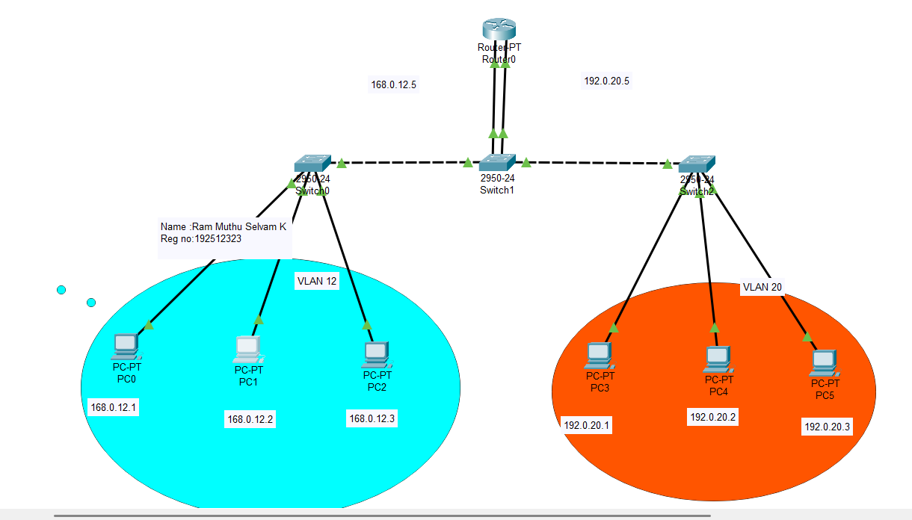

Output:
Objective 1: VLAN Configuration

SI.  No | Source IP | Destination IP | Data sent (bytes) | Data received (bytes)
1. | 196.0.20.1 | 168.0.12.3 | 4 | 0
2. | 196.0.20.3 | 192.0.20.2 | 4 | 4
3. | 168.0.12.1 | 168.0.12.2 | 4 | 4
4. | 168.0.12.2 | 196.0.20.3 | 4 | 0
5. | 168.0.12.3 | 196.0.20.1 | 4 | 0

Objective 2: Inter-VLAN Configuration

SI.  No | Source IP | Destination IP | Data sent (bytes) | Data received (bytes)
1. | 196.0.20.1 | 168.0.12.1 | 4 | 3
2. | 196.0.20.1 | 168.0.12.1 | 4 | 4
3. | 168.0.12.1 | 196.0.20.1 | 4 | 4
4. | 196.0.20.1 | 196.0.20.3 | 4 | 4
5. | 168.0.12.1 | 168.0.12.3 | 4 | 4

Result:

Objective 1: VLAN Configuration
The VLANs were successfully configured, and communication was established only between devices within the same VLAN while communication between different VLANs was restricted.
Objective 2: Inter-VLAN Configuration
- Inter-VLAN Routing was successfully configured, enabling communication between devices belonging to different VLANs through the router.

